Robert Palmer
Bio 304
Review Paper
4/29/2010

Review of “Creating Bacterial Strains From Genomes That Have Been Cloned and Engineered in Yeast”
Lartigue et al.
The authors of this paper sought to display the results of what they deemed a successful experiment involving the transplantation of a genome from Mycoplasma mycoides, cloned and engineered within yeast, into M. capricolum.
Summary:
The researchers first had to prepare a bacterial genome for transformation into yeast. M. mycoides was first transformed with a yeast vector, containing genes essential for selection and propagation of the vector as well as a tetracycline-resistance marker for easy identification of transformed cell lines. They confirmed the integration of the vector into the bacterial genome by direct sequencing and ensured that it was indeed capable of being transplanted into the eventual recipient, M. capricolum. They then isolated these genomes and used them to transform yeast, where they cloned and engineered the genome. They decided to label the M. mycoides genome as YCpMmyc1.1.
Figure 1A
Figure 1A indicates, through graphic representation, how the researchers were able to engineer the seamless deletion of the nonessential type III restriction endonuclease gene of the bacterial M. mycoides genome in yeast.

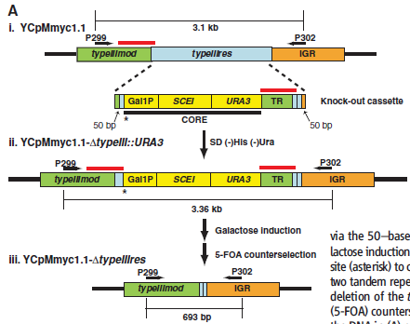
The experimenters were able to use yeast gene alteration methods, previously unavailable to them within the native bacteria, to alter the bacterial genome, YCpMmyc1.1. In this particular experiment, they engineered the bacterial genome by deleting a non-essential type III restriction endonuclease site in two yeast strains. To achieve this, they created a knockout cassette by fusing a core sequence, containing a URA3 marker, a SCEI endonuclease gene downstream of a GAL1 promoter, and a tandem repeat sequence. When selected for by growth in a (-)HIS(-)URA medium, the knockout cassette replaced the type III restriction endonuclease gene by two 50 bp sequence target sites. They then induced expression of the SCEI endonuclease gene, located in the cassette, using galactose to intiate its GAL1 promoter. The endonuclease cleaved the DNA at a site just upstream of the GAL1 promoter to create a double strand break capable of homologous recombination. Through this recombination between the tandem repeat sequences, the cassette was removed and the seamless deletion of the type III restriction endonuclease gene was completed. They then used 5-Flouroorotic acid ( 5-FOA) counterselection to select against the URA3 marker and isolate the engineered genome with the cassette removed. Genomes were then transplanted into M. capricolum recipient cells.
Figure 1B
The researchers used two primers, which flanked the type III restriction endonuclease gene (P299 and P302 as seen in figure 1) to run a PCR so that they could verify the presence or absence of the knockout cassette in cloned genomes. Figure 1B shows the results they obtained.

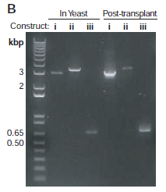
3.1 kb
.693 kb
3.36 kb

The un-engineered YCpMmyc1.1 genome was run in the first lane of both the yeast and the post-transplant clones (i) as a control, and clone YCpMmyc1.1 genomes with (ii) or without (iii) the cassette were run in the next two lanes of both lineages. The bases, in kb, of the fragment between the primers used for PCR are shown in figure 1A for each of the genomes represented in this figure. In both the yeast and the post transplant bacteria, one can discern a small increase in the size of the DNA from lane (i) (3.1 kb), containing the unmodified YCpMmyc1.1 genome, to lane (ii) (3.36 kb), containing the DNA fragment which possesses the knockout cassette instead of the type III restriction endonuclease. This increase in size is expected because the knockout cassette is longer than the original type III restriction endonuclease gene. In lane (iii) (.693 kb) of both the yeast and the post-transplant bacteria, a large decrease in the size of the DNA can be seen, indicating the absence of the cassette via galactose induction of the SCE1 endonuclease contained in the cassette open reading frame. Lane (iii) represents the successful seamless deletion of the targeted gene within transplant populations of M. capricolum.

The authors of this paper ran into some trouble with the actual transplantation of the YCpMmyc1.1 into the wild-type M. capricolum cells. They were unable to obtain viable transplant colonies. Assuming that this was due to restriction endonucleases of the M. capricolum cells digesting the foreign DNA transplants, they used two methods to circumvent this problem. In one method, they inactivated the single restriction endonuclease gene of M. capricolum by inserting a resistance marker directly into the endonuclease gene. In another method, they sought to protect the transplant DNA by in vitro methylation using extracts from either M. mycoides, M. capricolum, or purified methyltransferases.
Table 1
This table shows the average number of tetracycline-resistant (marker for transplant), blue colonies grown on a tetracycline medium after transplantation of the YCpMmyc1.1 genomes into either wild type or restriction endonuclease deficient M. capricolum cells.

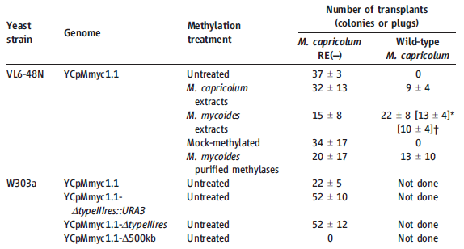

From left to right, this table contains columns indicating which strain of yeast the transplant came from, what sort of modifications were done to the genome, what kind of methylation treatment the genomes were exposed to, and columns indicating the number of colonies obtained from transplantation into either M. capricolum RE(-) (restriction endonuclease inactivated) or wild-type M. capricolum. Both treated and untreated sampes were exposed to β-agarase, in what is called a melting step. The treated and mock-methylated samples were both treated with proteinase K (to get rid of proteins. i.e. methyltransferases) and melted. The treated samples were methylated in this process before melting and the mock sample was left unmethylated. Using the M. capricolum RE(-) recipient cells, colonies were obtained from every transplant procedure, excluding the YCpMmyc1.1-∆500kb genome, which contains a large deletion and is not expected to be viable (red box). The wild-type recipient cells would only receive transplant DNA which had undergone methylation via extracts from either bacteria or purified methyltransferases, and no colonies were obtained from the untreated and mock-methylated transplants (red arrows). This demonstrates the importance of the recipient restriction system in genome transplantation.

Figure 2A
Figure 2A confirms that the colonies of transplanted cells actually contain the M. mycoides transplant genome by Southern blot analysis.

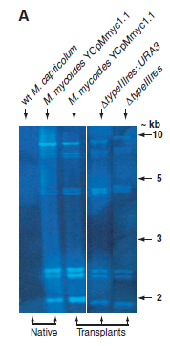
Hind III restriction enzyme was used to digest DNA from the native bacteria strains, as well as from transplants containing both the engineered and unmodified genomes derived from the M. mycoides YCpMmyc1.1 genome. In this southern blot, the DNA was probed with IS1296 sequences, specific to the M. mycoides genome. The same band pattern appears in every column that you would expect, given the experiment was performed correctly and the genome was successfully transplanted. The band pattern appears in the native (positive control) and transplant M. mycoides YCpMmyc1.1 strands, the genome containing the cassette in place of the type III restriction endonuclease (∆typeIIIres::URA3), and the genome containing the full, seamless deletion of the type III restriction endonuclease (∆typeIIIres). This figure supports the claim that they have successfully transplanted the M. mycoides genome. The wt M. capricolum genome was run in the first lane and contains no bands (negative control).

Figure 2B
This figure helps confirm the deletion of the type III restriction gene in the engineered bacteria by Southern blot analysis

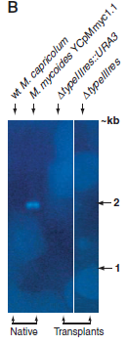
This is another Southern blot like the one in figure 2A; however, this blot uses a probe specific for the type III restriction endonuclease gene and uses a different restriction enzyme. The native bacteria strains were run in the first two lanes, and the engineered transplant genomes were run in the last two lanes. Because the type III restriction endonuclease is unique to M. mycoides, one would not expect to see a band in the M. capricolum lane, and, in fact, there is no band present in that lane (control). The transplant engineered genomes also lack the type III restriction endonuclease gene, either because it has been replaced by the cassette (lane 3 from left to right), or because it has been completely deleted (lane furthest to the right). As expected, there are no detectable bands in these lanes as well. The only detectable band is in the native M. mycoides YCpMmyc1.1 lane (red arrow), which, seeing as it is unmodified and represents the complete genome of this bacteria, is expected. Thus, in the engineered genomes no bands were detected, which supports the authors claim that the type III restriction endonuclease gene was deleted.

Figure 2C
The researchers decided to sequence the locus of the type III restriction endonuclease gene to ensure that it was deleted.

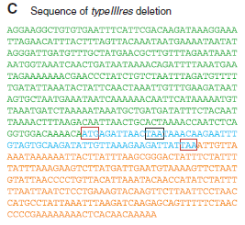

Direct sequencing of the locus confirmed the deletion of the type III restriction endonuclease from the genome. The colors correspond to those in the genetic map in figure 1A. The green sequence is part of the typeIIImod neighbor and the orange sequence is part of the IGR neighbor. The blue letters indicate a small part of the type III restriction endonuclease gene that was left behind because of an overlap with its typeIIImod neighbor. The two red boxes represent the start and stop codons of the type III restriction endonuclease, and the black box represents the stop codon for the typeIIImod gene.
Figure 3
Figure 3 is a visual representation of transforming yeast with a bacterial genome, engineering it, and then transplanting it back into bacterial recipient cells. It also demonstrates that the process can be carried out in a cyclical manner to continuously introduce new traits.

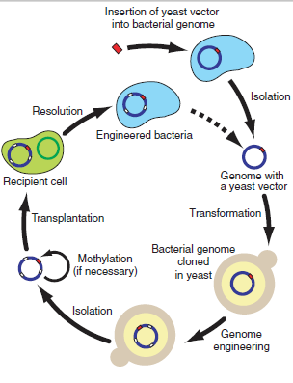
Critique:
Overall, this paper was convincing. They set out to move a bacterial genome into yeast, engineer it in yeast, and then place it back into a recipient bacterial cell. They used multiple different methods to verify that their in yeast knock out cassette deletion of a gene in the YCpMmyc1.1 genome worked, and that the engineered genomes were reinstalled into bacteria. The authors’ goal was to introduce a new method of genetic manipulation, specifically in mycoplasmas. It would seem that they achieved this goal; however, the paper did raise a few questions.
Referring to figure 1B
One can clearly see the changes in length of the segments corresponding to insertion of the knockout cassette and the deletion of the targeted gene (arrows with corresponding kb noted in the above diagram). They ran PCR for both the genome within yeast and after transplantation, or reinstallation, back into bacteria. This helps to support their claim that the engineered genomes are actually making into recipient bacterial cells and that these cells are viable. This figure was well presented.
Referring to table 1
This table is well organized and clearly indicates the importance of dealing with the restriction endonucleases within the recipient cell when transplanting genomes. Methylation of the genomes being transplanted or inactivation of the recipient cells endonucleases both proved effective in recovering viable transplant colonies. However, there were a few numbers that could have used a better explanation. The paper says that the W303A yeast derived YCpMmyc1.1, YCpMmyc1.1-∆typeIIIres::URA3, and YCpMmyc1.1-∆typeIIIres all produced a similar number of colonies when transplanted into M. capricolum RE(-). The YCpMmyc1.1 genome that possesses the typeIIIres gene seems to produce far less colonies (22 +- 5) on average than the cassette and full deletion genomes, which produce fairly similar averages (about 52+- 12). Why does this occur, and why does the paper skim over it? More experiments should be performed to determine if the averages remain the same, or begin to look more similar.

Referring to figure 2A
The Southern blot test to determine the presence of the M. mycoides genome within the transplants is convincing. They set up a negative and a positive control for their YCpMmyc1.1 specific probe in the first two lanes. The wt M. capricolum does not possess the yeast vector M. mycoides genome, and the probe should not bind. As expected, there are no bands within this lane. The native, meaning not transplanted into yeast or another bacteria, M. mycoides lane does show a distinctive band pattern. If the transplants took up the same or slightly modified genomes, they should show the same band pattern, and they do. There might be one issue with this gel, and that’s the absence of a loading control. In the negative control, M. capricolum, lane we cannot be certain that no mistakes were made, and that the DNA was actually loaded into the well. If they would have probed the well with another probe to confirm the presence of DNA within the well, it may help to confirm that no mistakes were made in filling the wells.

Referring to figure 2B
This experiment could have been a little clearer. They did another Southern blot using a probe specific for the type III restriction endonuclease they claimed to have removed from the M. mycoides genome. They used M. capricolum as a control because it does not contain the typeIIIres gene, and, as expected, no band is seen in the lane. In the genome including the cassette and the genome with the seamless deletion no bands are seen because the target gene has been successfully removed. The only band seen in this diagram is in the lane containing DNA from native M. mycoides, which makes sense considering the gene is unique to this bacteria. Overall, it is convincing, but, once again, there are multiple empty lanes with no indicator that DNA was even inserted into the wells. It would strengthen this figure if there was some sort of loading control to ensure that DNA was actually loaded into the lanes. Also, possibly another experiment could be done using a probe that selectively binds to a sequence within the knock out cassette and/or with a probe that binds to the sequence created when seamless deletion occurs. This would lend to a figure with more positive feedback than negative feedback. Also, it would be nice to see a lane with DNA from the transplant of YCpMmyc1.1, which has been left out from this figure.
Referring to figure 2C
This figure is simply a DNA sequence showing that the typeIIIres gene has been effectively deleted. It may behoove them to show a sequence of the unmodified YCpMmyc1.1 genome to better display the deletion. Also, the authors of this paper call the deletion seamless; however, there is, although small, a segment of DNA from the typeIIIres gene still present. They say the segment of typeIIIres is there because of an overlap with its neighboring typeIIImod gene. If that is so, then how come they have not deleted the segment after the typeIIImod stop codon which does not overlap? This question could have been addressed.

Future Experiments:
Experimental flaws and possible follow up experiments were pointed out in the critique. For example, the Southern blot experiments could have included some kind of evidence that ensures the reader that all wells in the gel contain DNA. On a similar note, more positive results could be obtained in the Souther blots using probes specific to the deletion sequence as well as probes specific to the knockout cassette. Also, more transplantation experiments could be done to determine why the average number of colonies recovered from YCpMmyc1.1 (table 1) were fewer than transplantations using the engineered genomes.
This paper has introduced a novel new method of manipulating bacterial genomes in ways never before possible. Further experiments should use this method to target genes of interest for deletion, insertions, and rearrangements. According to this paper, mycoplasmas are responsible for many diseases in ruminants. Future experiments could use this new method to answer questions relevant to their pathogenicity. For instance, which genes are responsible for the disease inducing phenotype of a particular mycoplasma? To achieve this, one could use the genome altering capabilities presented in this paper to target genes suspected of being involved in a particular disease of interest. By inactivating these genes, one can observe the phenotypes in vivo to determine whether the suspected genes are involved in making the bacteria a pathogen.
Another potential use for this method of genome alteration is in the exploitation of microbes in medicine. One could potentially engineer a bacteria capable of living in humans which could produce and secrete a protein of medicinal value. For example, one could place a medicinally relevant gene on what was the “knock out cassette” in this paper under the control of an appropriate promoter. The “knock out cassette” could then be spliced into a bacterial genome in yeast and transplanted into bacteria that live in the human intestines, for example. Therefore one could create a transformed bacterial colony capable of living in a particular environment and secreting a medicinally beneficial protein. Further research regarding this ought to be pursued.

